U.S. General Services Administration
Public Buildings Service

User Manual

Electronic Occupancy Agreement (eOA)

August 10, 2015

Table of Contents
1 Introduction 4
1.1 Purpose 4
1.2 General Description 4
1.3 Getting Started 5
1.3.1 Logon 6
1.3.2 Navigation 11
1.4 Search OAs 11
1.4.1 Search OA Criteria 11
1.4.2 Search OA Results 12
1.4.3 View OA Details 13
1.4.4 Rates History 15
1.4.5 Download/Save OA Details as PDF 16
1.5 OA Documents 16
1.5.1 Financial Summary 16
1.5.2 Signed Agreement 19
1.5.3 Preview Bill 24
1.5.4 Combined Signed Agreement and Financial Summary 25
2 Operating Instructions 28
2.1 Maintain Operation 28
2.2 Terminate and Restart Operation 28
3 Error Handling 28
4 Help Facilities 28

Illustrations

Figure 1: PBS Portal Extranet Logon Page 6
Figure 2: One-time Password Logon 7
Figure 3: Logon Validation 7
Figure 4: Logging in 8
Figure 5: Sending One Time Password 8
Figure 6: Enter Pin 9
Figure 7: PBS Portal Extranet Landing Page 9
Figure 8: eOA Portal Landing Page 10
Figure 9: eOA Home Page Screen 10
Figure 10: Top and Left Menu Navigation 11
Figure 11: Search OA Criteria Screen 12
Figure 12: OA Search Results Screen 12
Figure 13: OA Details Screen (top) 13
Figure 14: OA Details Screen (middle) 14
Figure 15: OA Details Screen (bottom) 15
Figure 16: Rates History Pop-Up Screen 16
Figure 17: Financial Summary Criteria 17
Figure 18: Generated Financial Summary 18
Figure 19: Signed Agreement Criteria 20
Figure 20: Generated Signed Agreement 21
Figure 21: Preview Bill Criteria 24
Figure 22: Generated Preview Bill 25
Figure 23: Combined Criteria 26
Figure 24: Generated Combined Signed Agreement and Financial Summary 27

Introduction
An Occupancy Agreement (OA) is a record of understanding between a client agency that uses space and the agency that controls the owned or leased space. Electronic Occupancy Agreement Tool (eOA) is a web-based extranet application that enables Agency and Public Building Services (PBS) users to view OAs in read-only mode. The system is accessed throught an external PBS Portal. Besides viewing OAs, users have the ability to view documents related to the OA.
The eOA application allows users to search for and view the details of an OA (occupancy agreement). They can also view the details as a PDF. Users can view all OAs for any agency to which the user has access. For example, a USDA employee can view USDA OAs. GSA users with access to OA Tool can view OAs for all agencies.
Users may also view several reports for an OA. Signed Agreement, Preview Billing, Financial Summary, and Combined documents are all available on the web and as a PDF.

Purpose
The purpose of eOA is to provide users from non-GSA agencies access to OAs, so they can verify that rent bills were charged accurately. They can also view rates history and OA documents.

General Description
In order to access eOA, users will need to get an account, which allows them to be authenticated and stores the user’s list of assigned agency/bureau codes. GSA users will have access to OAs from all agencies.
Users can perform a quick search on a specific OA, or search based on state, status, and agency. Results from the latter search can be sorted and filtered to help find exactly what the user is seeking. The details for an OA can be viewed in the application, and can be generated as a PDF.
Several documents can also be viewed and printed as a PDF: Signed Agreement, Financial Summary, Combined, and Preview Bill documents.

Getting Started
This section is intended to help familiarize users with the basics of accessing and navigating the system.
1) Go to www.gsa.gov/eoa and click on the Electronic Occupancy Agreement link. Information about eOA will be displayed. A User ID request form is also available here. Open the request form and follow the directions.
2) If approved, a confirmation e-mail will be sent providing a User ID and phone number to call for a temporary password.

Logon
- After receiving a user ID and password, enter the PBS Portal Extranet by going to https://extportal.pbs.gsa.gov and click the green “login” button located at the top center of the intro page.

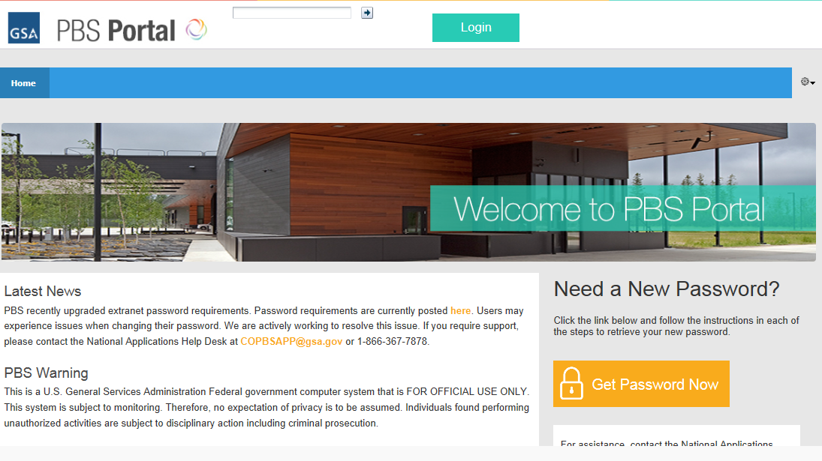
Figure 1: PBS Portal Extranet Logon Page

- Click to logon with One-Time Password

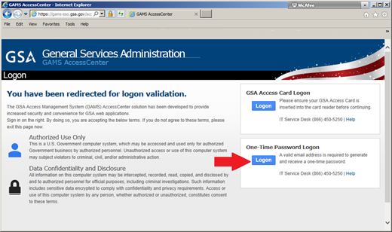
Figure 2: One-time Password Logon

- Enter username and password, and click Continue

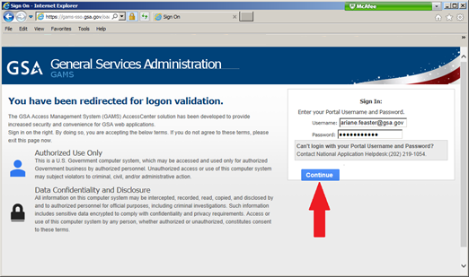
Figure 3: Logon Validation

- After clicking “Continue”, you will get the following two screens

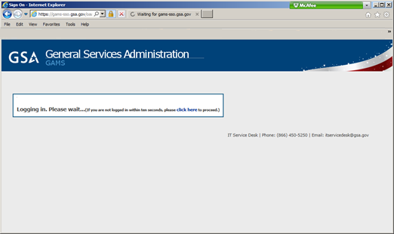
Figure 4: Logging in

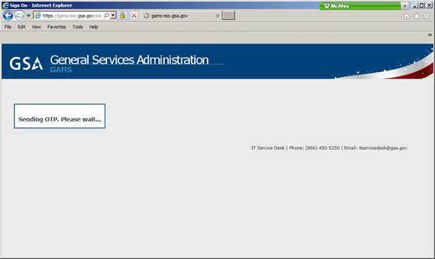
Figure 5: Sending One Time Password

- When you get the third screen (below), check your Agency email for the 5-digit pin, then enter it in the textbox and click “Enter”

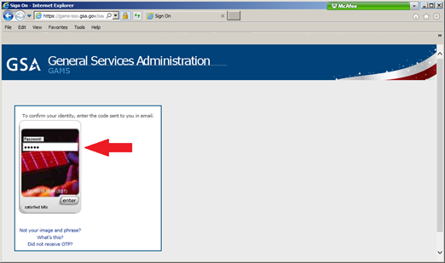
Figure 6: Enter Pin

- You will be taken to the PBS Portal. Select the eOA icon from the list of Extranet Applications.

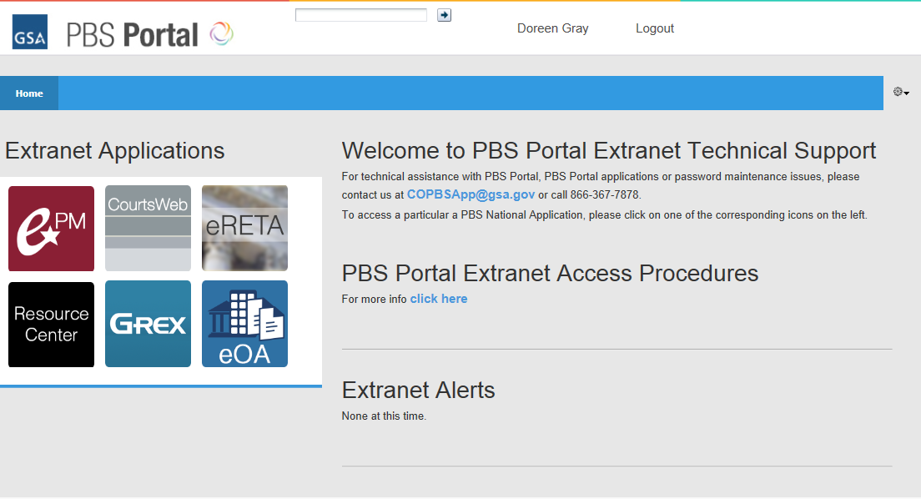
Figure 7: PBS Portal Extranet Landing Page
- Select the eOA icon to access the eOA application
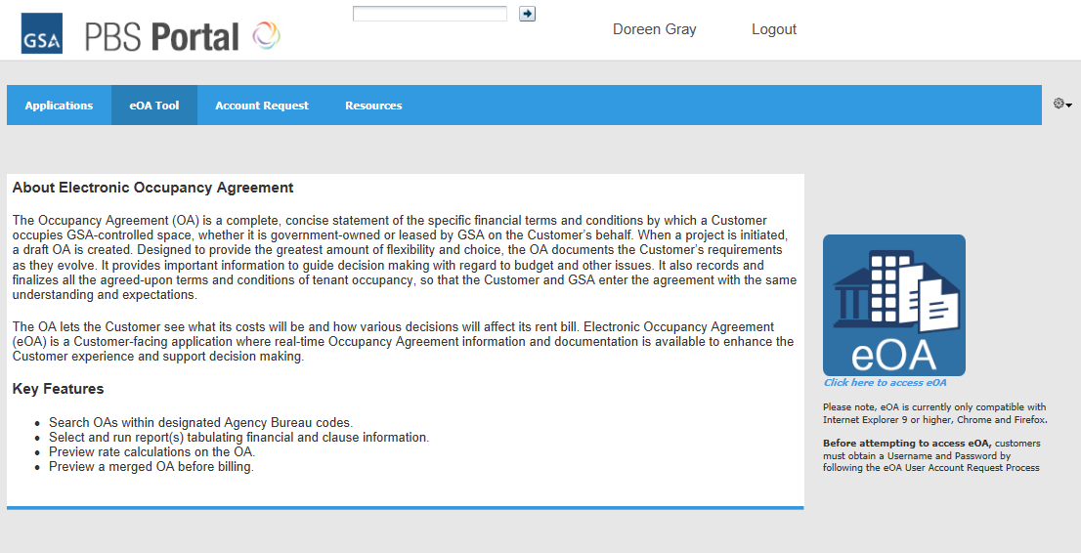
Figure 8: eOA Portal Landing Page

- After the eOA application launches, the eOA Home Page Screen displays the OA search section and left navigation.
Figure 9: eOA Home Page Screen

The Home page displays the OA search section.

Navigation
The navigation links located on the home page also exist on every other screen in the system and constitute the primary navigation mechanism.
Top Navigation
The top right corner of the home page features the Help and Logout links. Clicking the Help link will bring up an online copy of the User Manual. Clicking the Logout link will take the user back to the Portal.
OA Quick Search
Use the Quick Search feature to search for and open a known OA. Begin typing the first few letters of the OA you wish to view. After three letters are entered, the system begins searching for matching OAs that you have access to. Wait for the system to return a list of OAs. At this point, you can select one of them. Note: It’s faster to type more characters (instead of just “ADE”, type “ADE00”). This reduces the number of results you will see in the drop-down, from which to select an OA.
Once you have selected an OA, click the search (magnifying glass) icon. This will take you to the OA Details screen for the selected OA.

Left Navigation
The items listed on the left side are the following. All these screens are read-only for both Agency and PBS users:
- Home: Links to the home page, which in turn opens the Search screen.
- Search: Links to the OA Search screen.
- Reports: Links to the following four documents:
- Financial Summary
- Signed Agreement
- Preview Bill
- Combined Signed Agreement and Financial Summary

Figure 10: Top and Left Menu Navigation

Search OAs
The Search engine allows users to search for Final and Closed OAs.

Search OA Criteria
To search for OAs, follow the directions below:
- On the left menu bar, click on the Search or Home links. A screen containing the search engine will open.
Note: If you are an Agency user with one agency assigned to you, the Agency Bureau field will automatically be populated with your agency name in the Search criteria.

Figure 11: Search OA Criteria Screen

- Enter valid information into one or more of the search criteria available in the engine. Each of the search criteria fields is optional except for the Status (Final or Closed) check-boxes.
- Click Search to submit your search criteria or Reset to erase your selections.

Search OA Results
Once a search has been submitted, a screen containing the OA search results listings will appear under the Search criteria. The number of search results found is listed as well as the number of rows displayed per page.
Figure 12: OA Search Results Screen
For each listed OA, the system provides its OA Number – Version Number, Status, OA Type, A/B Code, Location Code, Effective Date and Expiration Date. The results are initially sorted by the OA Number – Version Number but may be sorted by any of the columns in ascending or descending order by clicking the column headings. Each row in the table is a link to the OA Details screen.
When OA results are listed, a Filter keyword search is available. Using this filter, you may narrow down the search results. Any entered value(s) is searched against all the columns that are displayed in the Search Results.

View OA Details
To view the details of an OA, click on the OA Number in the OA Search results. This will open a screen with the OA Details. The OA Details contains various OA information such as Location, Space/Parking, Rates, Joint Use charges, Billing Adjustments, Escalations, Tenant Improvements and Forced Move. For more information, please see Figures 13-15.
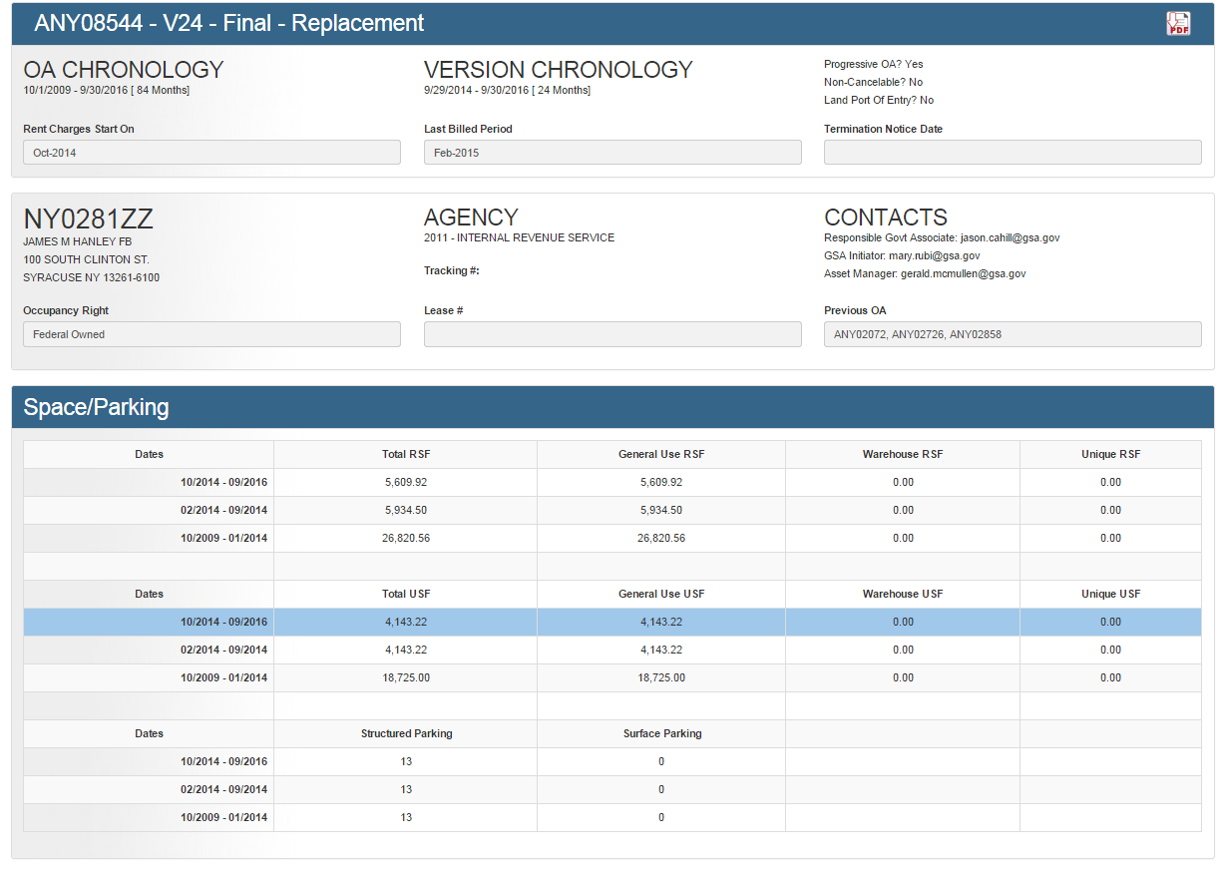
Figure 13: OA Details Screen (top)
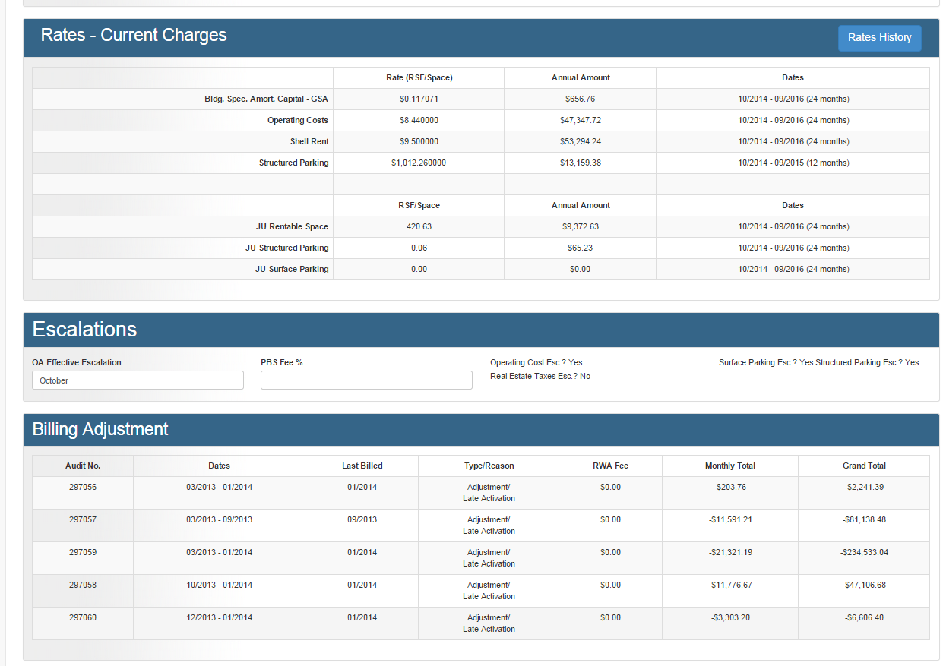
Figure 14: OA Details Screen (middle)
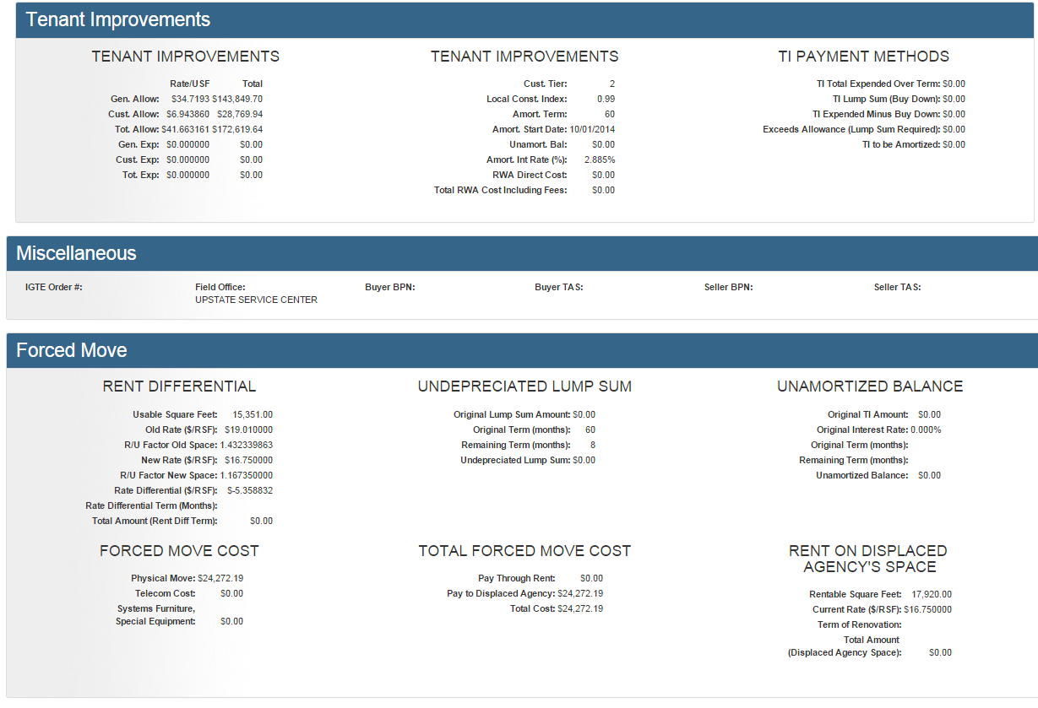
Figure 15: OA Details Screen (bottom)

Rates History
The Rates History screen contains all billed charges on an OA, in addition to the current and future billed charges. To view the Rates History, perform the following steps:
On the OA Details screen, click on the Rates History. A pop-up screen will open where all the OA rates (including Joint Use rates) are listed:
Figure 16: Rates History Pop-Up Screen
To close the Rates Hstory, click on the X sign at the top-right corner.

Download/Save OA Details as PDF
To downloads/save the OA Details, click on the PDF icon. This will download the OA Details to your local machine. Note: this feature currently works in Chrome and IE10 or higher.

OA Documents
eOA provides four OA documents. These documents display financial data from OAs. In addition, they are available in PDF Format.

Financial Summary
The Financial Summary Report (FSR) displays financial details of the Occupancy Agreement (space and rates paid). An FSR is generated for a specified time period or entire OA Term. Each page of the report contains data for the sequential fiscal year or OA year or part of a FY or OA year. eOA features a search section to generate Financial Summary documents. This functionality is accessible from the Left Menu navigation.

Financial Summary Criteria
- From the Left Menu Bar, click Reports, and then click Financial Summary. The Financial Summary Document Criteria section will open as a pop-window within the left-menu.
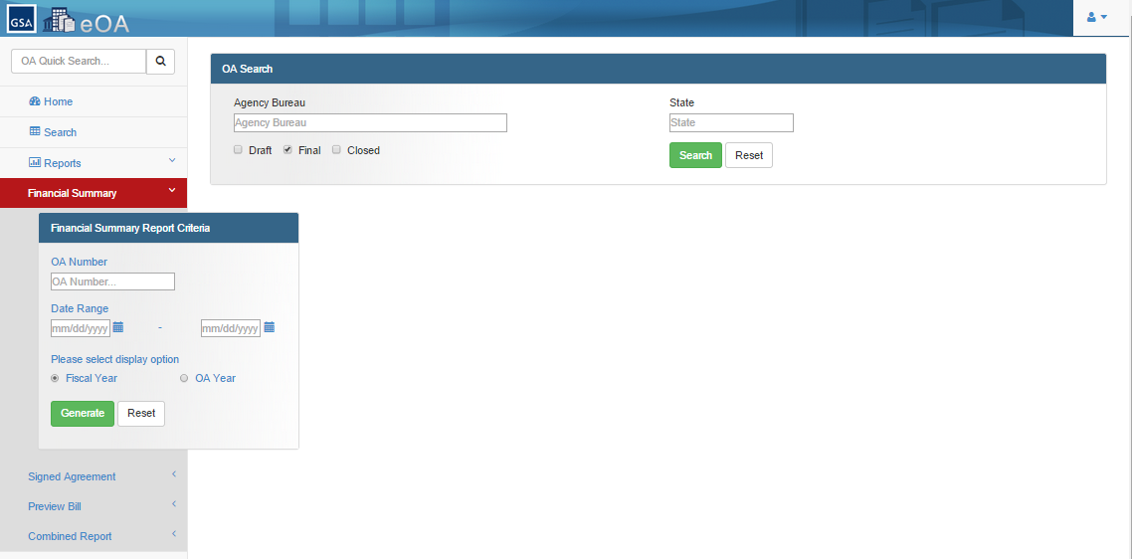
Figure 17: Financial Summary Criteria
- Enter valid information into one or more of the search criteria fields.
Note: When you enter the OA, system auto-populates the Effective and Expiration Dates from the selected OA version.
- Click Generate to generate the document or Reset to erase your criteria selection.
- Screen with HTML version of the document displays. To download a PDF version of the document, click on the icon.

Generate Financial Summary
If the search criteria you entered were valid, the system will generate the Financial Summary Document.
Figure 18: Generated Financial Summary

Report Header Information
In the header of the report, among other information, the following data is displayed:
- The Occupancy Agreement number and the OA Version number
- The Agency/Bureau Name
- The Lease Number
- The Period of the Report
- Supplemental Reason
- Agency Tracking Number
Detail Information
If different square footage or parking amounts exist within the period of the FSR, data for the applicable space/parking period is displayed on separate pages.
Financial Summary displays rates per rentable square foot. All rates are annualized. When different rates exist in the same financial year, the report will show the total annual amount for each year.
When a line item amount equals zero (Ø), the item is not printed on the report with an exception of Surface Parking, Structured Parking, and PBS Fees.
When the Surface and/or Structured Parking annual amount is zero and a number of parking spaces exist, the line is printed showing the number of parking spaces.
When the SQFT on an OA is zero, PBS Fee is still displayed and calculated by aggregating parking and space item annual amounts.
When escalations apply, Financial Summary displays a notation “*** Escalation Applies” for the line item in the footer of the report.
A note is displayed at the bottom of each page of the report with information about the square footage and R/U Factor, except for a version that does not have any square footage.
When a Free Space clause from the Optional Clauses section is added to the OA version, a note is displayed including the values entered of the clause variables, at the bottom of each page of the report.
Real Estate Tax Increase displays as lump sum amount and as a Billing Adjustment for the appropriate fiscal year and OA Year. If Shell Rent Rates expires prior to the expiration of OA and is not replaced with another Shell Rent Rate, Financial Summary Report will generate until the time it is replaced by another rate or insert TBD if there are no Shell Rent Rates. Financial Summary Report will perform Progressive Merge and will create Progressive OAs.

Signed Agreement
The Signed Agreement report displays the agreement between GSA and the client agency. It is generated to provide a signed copy of the Occupancy Agreement in the form of a report. When applicable, this report displays statements for Lump Sum Payment and Escalations. A signed agreement may have multiple signatures. eOA features a search section to generate Signed Agreement documents. This functionality is accessible from the Left Menu navigation.

Signed Agreement Criteria
- From the Left Menu Bar, click Reports, and then click Signed Agreement. The Signed Agreement Document Criteria section will open as a pop-window within the left-menu.
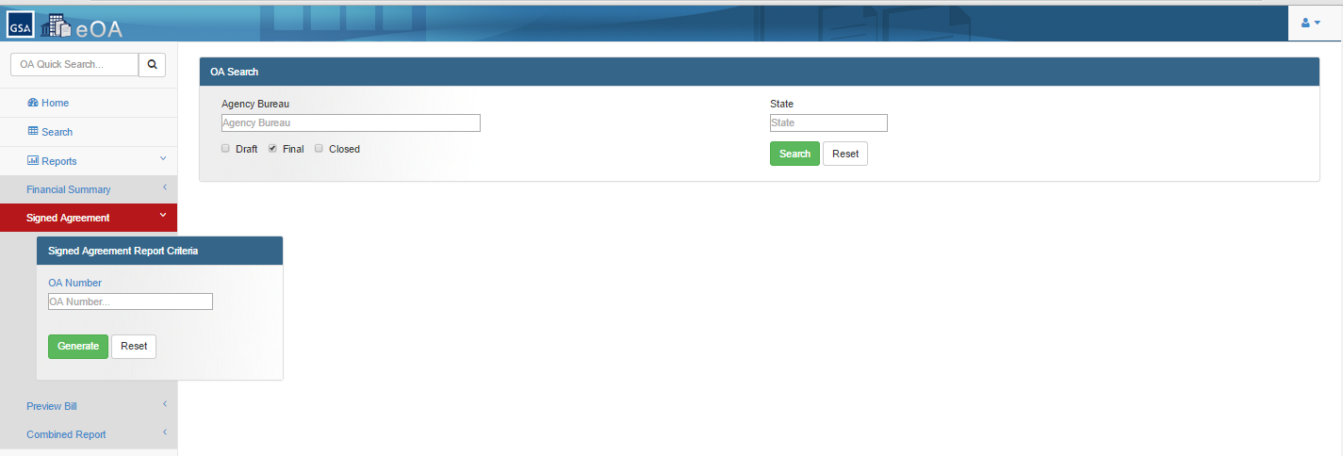
Figure 19: Signed Agreement Criteria
- Enter valid information into one or more of the search criteria fields.
Note: When you enter the OA, system auto-populates the Effective and Expiration Dates from the selected OA version.
- Click Generate to generate the document or Reset to erase your criteria selection.
- Screen with HTML version of the document displays. To download a PDF version of the document, click on the icon.

Generate Signed Agreeement
If the search criteria you entered were valid, the system will generate the Signed Agreement document.
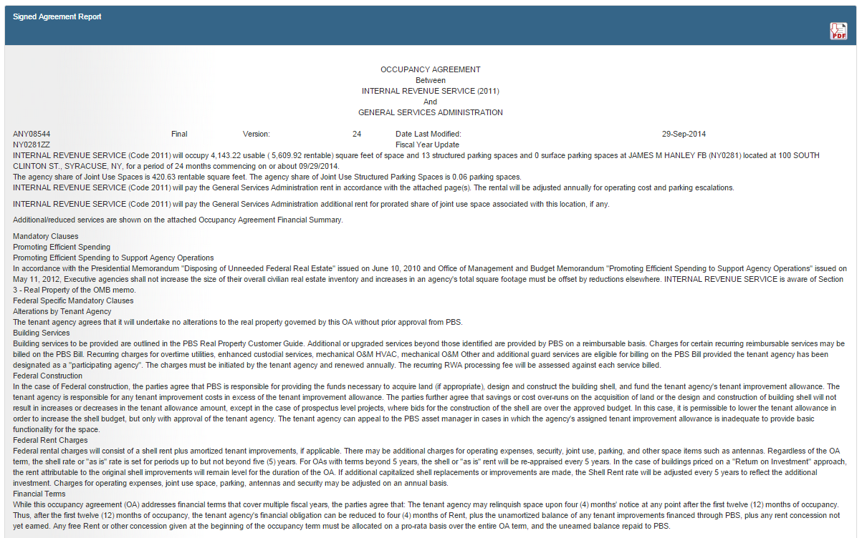
Figure 20: Generated Signed Agreement

The Signed Agreement header displays the following information:
- OA Number
- OA Version Number
- Date Last Modified
- OA Status
- Location Code
- Lease Number
- Supplemental reason code (and/or description)

Fields displayed include: Space Occupied, number of Structured and number of Surface Parking Spaces, Space Location, Lump Sum Payment, Operating Cost, Real Estate Tax Escalations, and Structured and Surface Parking Escalations.

Any clauses that apply to the occupancy agreement are listed in this report. The report order is as follows:
- Standard Clause
- GSA clauses (Federal/Lease/Postal)
For Federal Buildings
The following clauses are added to the OAs with the following Occupancy Rights: 1 (Federally Owned), 5 (Purchase Contract), 4 (Permit), 7 (Other/Special) or 8 (Portfolio Lease).
Federal Specific Mandatory Clauses
1. Financial Terms
2. Federal Construction
3. Building Services
4. Federal Rent Charges
5. Obligation to Pay Rent
6. Tenant Agency Move
7. Occupancy Agreement Iterations
8. PBS Services
9. Alterations by Tenant Agency
10. Payment by Tenant Improvements
11. Move Cost Responsibilities
12. Replacement Responsibilities

For Leased buildings
The clauses below are mandatory for Occupancy Rights 2 (Leased) or 3 (Nominal/Rent Free – Leased).
Leased Specific Mandatory Clauses
1. Financial terms
2. Tenant Agency Appeal
3. Building Services
4. Lease Contract Rent
5. Obligation to Pay Rent
6. Tenant Agency Move
7. Occupancy Agreement Iterations
8. PBS Services
9. Alterations by Tenant Agency
10. Payment by Tenant Improvements
11. Move Cost Responsibilities
12. Replacement Responsibilities

For Postal Office Buildings
The clauses specified below are mandatory for all Occupancy Agreements for Occupancy Right 6 (Postal).
Postal Building Specific Mandatory Clauses
1. Financial terms
2. Tenant Agency Appeal
3. Building Services
4. Lease Contract Rent
5. Obligation to Pay Rent
6. Tenant Agency Move
7. Occupancy Agreement Iterations
8. PBS Services
9. Alterations by Tenant Agency
10. Payment by Tenant Improvements
11. Move Cost Responsibilities
12. Replacement Responsibilities

- PBS
Miscellaneous Clauses
1. Non-Cancelable Space
2. Non-Cancelable Space with Occupancy Right 2 or 3
3. Space Item of Antenna if selected/entered
4. Tenant Improvement Cost
5. Tenant Improvement Lump Sum Cost

- Optional Clauses for All OAs
The following clauses may be added to all OA’s
  - New Construction or Building Modernization ROI Pricing
  - Convert Existing Property to ROI Pricing
- Agency/Bureau
- Regional Clauses
- Ad Hoc Clauses

Preview Bill
The OA Preview Bill report displays financial details of the Occupancy Agreement (space and rates paid) for a specified month. eOA features a search section to generate Preview Bill documents. This functionality is accessible from the Left Menu navigation.

Preview Bill Criteria
- From the Left Menu Bar, click Reports, and then click Preview Bill. The Preview Bill Report Criteria section will open as a pop-window within the left-menu.
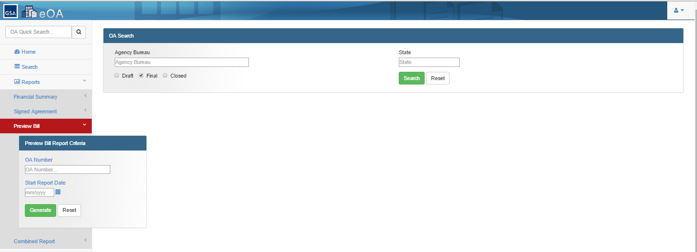
Figure 21: Preview Bill Criteria
- Enter valid information into one or more of the search criteria fields.
- Click Generate to generate the document or Reset to erase your criteria selection.
- Screen with HTML version of the document displays. To download a PDF version of the document, click on the icon.

Generate Preview Bill
If the search criteria you entered were valid, the system will generate the Preview Bill document.
Figure 22: Generated Preview Bill
Cost items that were escalated in Financial Summary Report will not be escalated in the OA Preview Bill report. The OA Preview Bill report will display the back billing amount for each month in the Billing Adjustment section.

The back billing amount includes the following rates from the rates screen:
- PBS fees
- Rent Component
- Rent Component for other space
- Billing Adjustment
- JU rates
In addition:
- When a Free Space clause from the Optional Clauses section is added to the OA version, a note is displayed including the values entered of the clause variables, at the bottom of each page of the report.
- A note is displayed at the bottom of each page of the report with information about the square footage and R/U Factor, except for a version that does not have any square footage.

Combined Signed Agreement and Financial Summary
This report is a combination of the Signed Agreement and the Financial Summary reports and is frequently referred to as the Combined Report. A user may view this report in Adobe Acrobat format ( PDF).
The Combined Report can be generated for one OA or all OAs, for a specific Agency or Location Code. eOA features a search section to generate Combined Signed Agreement and Financial Summary documents. This functionality is accessible from the Left Menu navigation.

Combined Signed Agreement and Financial Summary
- From the Left Menu Bar, click Reports, and then click Combined Report. The Signed Agreement and Financial Summary Report Criteria section will open as a pop-window within the left-menu.
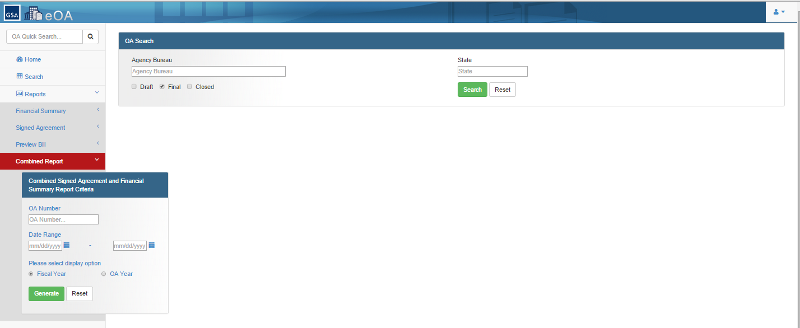
Figure 23: Combined Criteria
- Enter valid information into one or more of the search criteria fields.
- Click Generate to generate the document or Reset to erase your criteria selection.
- The PDF version of the document will display.
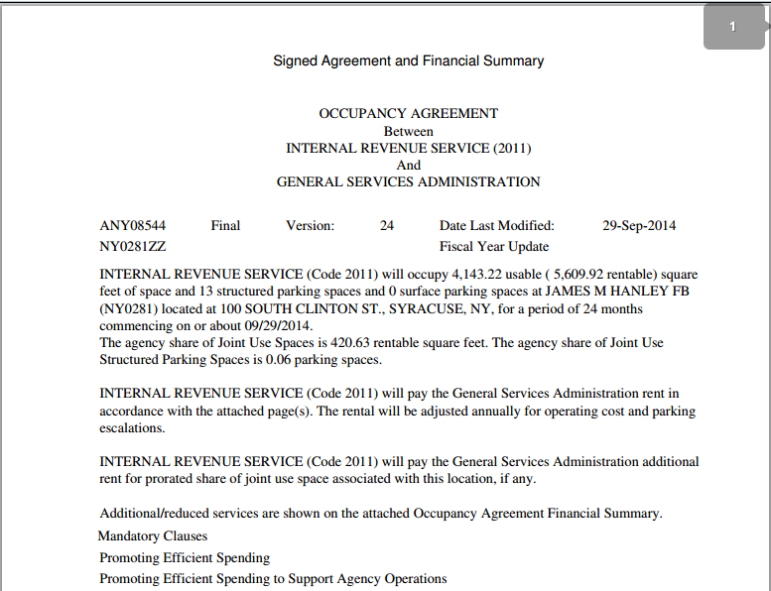
Figure 24: Generated Combined Signed Agreement and Financial Summary

Operating Instructions

Maintain Operation
Since eOA is a web application, users do not need to install any software. The only maintenance activities required for eOA are:
- to keep an active extranet Portal account, and
- participate in the user role recertification that occurs yearly.

Terminate and Restart Operation
Users access eOA via the extranet Portal. Occasionally, you may get an application error. While this may cause the current task you are working on to abort, you should be able to navigate to another page in the system without shutting the application down.
Occasionally, system problems occur which may require you to shut down your current browser window (clicking on the X in the top right corner of your browser window) and re-launch it from the eOA icon on the Portal. Even less frequently, you may have to close all browsers you have open and log into the Portal once again.

Error Handling
eOA displays error messages on the screen to indicate what validations failed or conditions were not met in order to process the user action.

Help Facilities
COPBSApp@gsa.gov
Local Number: (202) 219-1054
National Number: 866-367-7878

